🎯 Precision vs. Recall – Clear Understanding
Imagine you're building a spam email detector.
- Goal: Predict whether an email is spam or not spam.
There are 4 possible outcomes in any classification problem:
 | Predicted: Spam | Predicted: Not Spam
Actual: Spam | ✅ True Positive (TP) | ❌ False Negative (FN)
Actual: Not Spam | ❌ False Positive (FP) | ✅ True Negative (TN)

🔎 What is Precision?
Precision = How many predicted spams were actually spam?
Formula:
Precision = TP / (TP + FP)
📌 Example:
- Model predicted 100 emails as spam.
- 80 were actually spam → True Positives (TP)
- 20 were wrongly predicted as spam → False Positives (FP)
Precision = 80 / (80 + 20) = 0.80 or 80%
✅ Interpretation:
Out of all emails your model called spam, 80% were correct.
High precision = few false alarms.

🔁 What is Recall?
Recall = How many of the actual spams did the model catch?
Formula:
Recall = TP / (TP + FN)
📌 Example:
- There were 120 spam emails in total.
- Model caught 80 of them → TP
- Missed 40 of them → FN
Recall = 80 / (80 + 40) = 0.666 or 66.6%
✅ Interpretation:
Out of all real spam emails, your model caught 66.6%.
High recall = fewer missed actual cases.

🎯 Summary Table:
Metric | Focuses On | Good When You Want...
Precision | Being accurate in positive predictions | Avoid false alarms (e.g., important emails marked spam)
Recall | Catching all actual positives | Catch all true cases (e.g., no spam escapes detection)

🤔 Final Tip for Students:
Think of Precision as “How precise is your aim?”
Think of Recall as “How much did you remember to catch?”

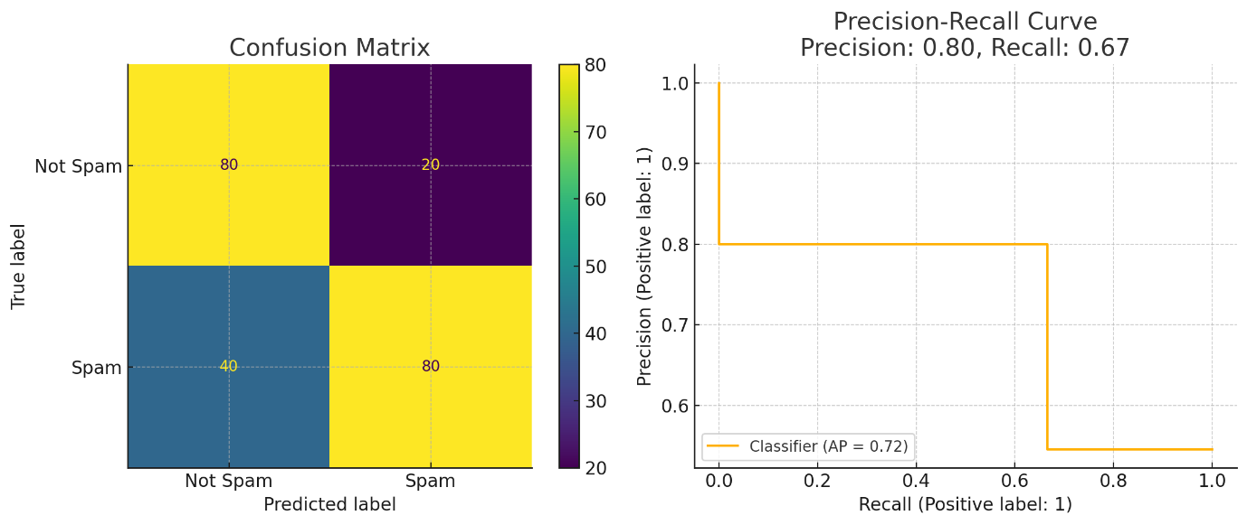
Here is the visual explanation:
📊 Left: Confusion Matrix
- 80 True Positives (Spam correctly identified)
- 20 False Positives (Not spam wrongly marked as spam)
- 40 False Negatives (Spam missed)
- 80 True Negatives (Not spam correctly ignored)
📈 Right: Precision-Recall Curve
- Shows the trade-off between catching more spams (Recall) and making fewer mistakes (Precision).
Here is a Precision-Recall Checklist / Thumb Rule Guide that help decide which metric to focus on — and how to get the best results depending on the scenario.

✅ Precision vs Recall: Checklist & Thumb Rules
🔍 Scenario | 🎯 Focus On | ✅ Why?
Spam Detection / Email Filtering | Precision | Avoid marking important mails as spam (false alarms).
Disease Diagnosis (e.g., cancer detection) | Recall | Catch all real cases, even if a few false alarms occur.
Credit Card Fraud Detection | Recall + Precision | High recall to catch fraud, high precision to avoid blocking real users.
Search Engines / Recommendations | Precision | Show only most relevant results to users.
Face Recognition for Unlock | Precision | Don’t unlock device for wrong person.
Criminal Identification from CCTV | Recall | Don’t miss any suspect.
Ad Click Prediction / Marketing Targeting | Precision | Don’t waste money showing ads to uninterested users.
Self-driving Cars – Obstacle Detection | Recall | Must detect all obstacles to prevent accidents.

🎯 General Thumb Rules:
✅ When to prefer Precision:
- False positives are costly (e.g., wrongful accusations, false spam).
- You want to be sure about positive predictions.
- Quality > Quantity in results.
✅ When to prefer Recall:
- False negatives are dangerous (e.g., missed disease, missed fraud).
- You want to catch as many true positives as possible.
- Quantity > Quality in detection.

🧠 Best Practices to Improve Precision & Recall:
🔧 Technique | 📝 Description
Data Balancing | Use SMOTE, oversampling, or undersampling for imbalanced datasets.
Threshold Tuning | Adjust classification probability threshold to trade-off precision vs recall.
Feature Engineering | Add meaningful features (domain knowledge helps).
Remove Noisy Labels | Clean data to avoid mislabeling (false learning).
Cross-validation | Use k-fold to avoid overfitting on precision or recall.
Ensemble Methods | Use Random Forest, XGBoost, etc., for better generalization.
Confusion Matrix Analysis | Evaluate TP/FP/FN/TN after each model improvement.
Precision-Recall Curve | Analyze PR curve to select best operating point.

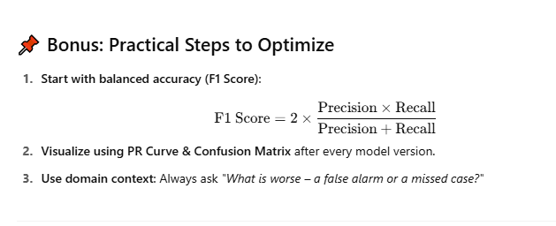
Layman's explanation of Precision and Recall using simple storytelling and real-world analogies

🎯 Imagine this: A Security Guard at a VIP Event
There’s a VIP party. Only people with invitation cards are allowed in. The security guard checks every person and decides whether to let them in or not.
Let's say:
- The guard is like your AI model.
- The people with real invites are the actual positives.
- The people allowed in by mistake without invites are false positives.
- The people with invites who are denied are false negatives.

✅ Precision = Of all the people the guard let in, how many were truly invited?
High Precision = Guard only lets in those with genuine invites.
- He’s super careful.
- But maybe he misses some invited guests because he's strict.
- Good for: when a mistake is dangerous.
- Example: Face recognition for unlocking your phone – You want only you to get in, not strangers.
🔍 Precision is about being exactly right when saying YES.

🔁 Recall = Of all the people who were actually invited, how many did the guard let in?
High Recall = Guard tries to let in everyone who has an invite.
- He doesn’t want to miss anyone important.
- But may let in a few people without invites too.
- Good for: when missing a case is risky.
- Example: Cancer detection – You want to catch all possible cancer cases, even if you flag some healthy people by mistake.
🔍 Recall is about finding as many YES cases as possible.

📖 Short Story: Lost Dog Alert System
Imagine you built an AI system that sends alerts when it spots a lost dog on security cameras:
- High Precision: Sends alerts only when it’s very sure it's the lost dog.
  - You get very few wrong alerts, but might miss the actual dog.
- High Recall: Sends alerts every time it sees any similar-looking dog.
  - You’ll definitely find the dog, but also get a lot of false alarms.

🧠 So when to use which?
Situation | Focus On | Why?
Medical tests (cancer, etc.) | Recall | Missing a real case is dangerous
Spam detection | Precision | You don’t want to lose an important email
Criminal search | Recall | Better to check more suspects than miss the real one
Fraud detection | Both (F1) | Catch all frauds but don’t block good customers

🔁 BONUS: F1 Score = The balance between Precision and Recall
It tells you how well your model does overall when both are important.

Complete story using a real-world scenario that explains Precision, Recall, False Positives, False Negatives, and even the F1 Score, in a way never forget:

🎬 Story: The Police Dog and the Bomb Detection Mission
🎯 The Mission
There’s a big international airport. The security team is using specially trained police dogs to sniff out bombs in passengers' luggage.
- The dogs bark if they detect a bomb (Prediction = Positive).
- No bark means no bomb detected (Prediction = Negative).
- The security team manually checks whether there actually was a bomb or not (Actual = Positive/Negative).

🧪 Four Real-World Outcomes
Case | Dog's Bark (Prediction) | Bomb Present (Reality) | What Is It Called?
1️⃣ | Barks | Bomb | ✅ True Positive (TP)
2️⃣ | Barks | No Bomb | ❌ False Positive (FP)
3️⃣ | Doesn’t Bark | Bomb | ❌ False Negative (FN)
4️⃣ | Doesn’t Bark | No Bomb | ✅ True Negative (TN)

🔍 Now, Let’s Break It Down
✅ Precision (Trustworthiness of Bark)
Precision = Of all the times the dog barked, how often was there actually a bomb?
- If the dog barks 10 times, but only 6 were real bombs:
Precision = 6 / 10 = 60%
- High precision = The dog barks only when there is really a bomb.
- Useful when false alarms are costly (e.g. emergency evacuations).
🎯 Real-world analogy: Precision is like how trustworthy is a fire alarm? Does it go off only when there’s real fire?

🔁 Recall (Sniffing Power)
Recall = Of all the real bombs, how many did the dog actually catch?
- If there were 10 real bombs, and the dog only caught 6:
Recall = 6 / 10 = 60%
- High recall = The dog finds almost every bomb, even if some weren’t real.
- Useful when missing a case is very risky (e.g. bomb goes off = disaster).
🎯 Real-world analogy: Recall is like how many real criminals a CCTV system catches, even if it occasionally flags innocent people.

⚖️ F1 Score (Balance between Precision & Recall)
F1 Score = 2 * (Precision * Recall) / (Precision + Recall)
- When you want a balance, like in fraud detection.
- Neither too many false alarms, nor missing real threats.

📌 Summary with Real-World Use Cases
Situation | Focus | Why?
Bomb detection | Recall | Missing one is a disaster
VIP access scanner | Precision | Don't let unauthorized people in
Disease detection | Recall | Catch all possible cases, even false alarms
Email spam filter | Precision | Don’t throw important emails into spam
Fraudulent transaction alert | F1 Score | Balance: Catch frauds but avoid blocking genuine

💡 Memory Trick
"PRECISION = PICKY"
– Only raises alarm when really sure.
"RECALL = REMEMBERING"
– Tries to catch everything, even if not perfect.

🧠 Final Thought
- Want Precision when false alarms are expensive (e.g. hospital admits).
- Want Recall when missing a positive is dangerous (e.g. cancer cases).
- Want F1 Score when you need balance.

